**Homework 4**

**Task 1: Surveillance Techniques**

**Port Scanning**

**Design:** In this task I use the Kali VM that has nmap pre-installed to perform 5 different network surveillance techniques on the other VM such as: TCP connect scan, SYN stealth scan, FIN scan, Ping scan, UDP scan.

**Observation:** The command and result for each technique is as below:

*TCP connect scan: The TCP open ports were listed with different services.*

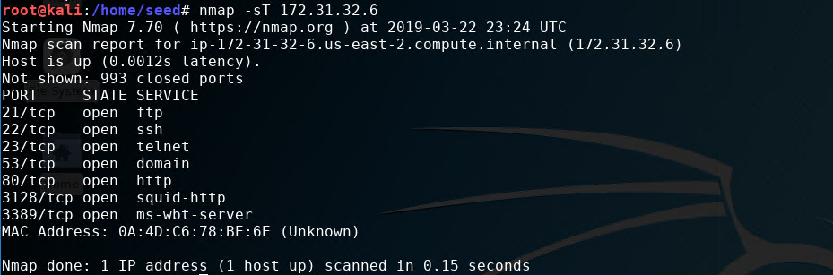

SYN stealth scan: *The TCP open ports were listed with different services. Result is similar to TCP connect scan but running time is much faster.*

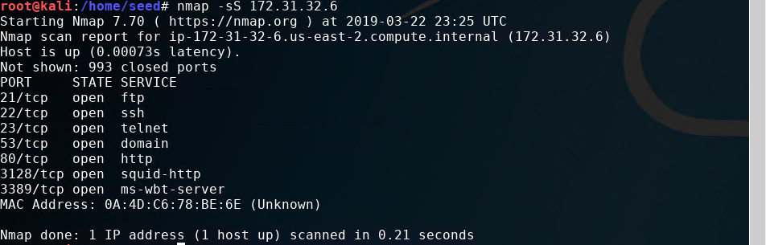

*FIN scan: The result is similar to TCP connect scan and almost as fast as SYN stealth scan*

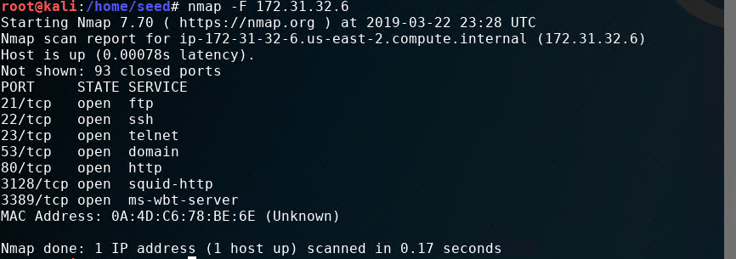

*UDP scan: This scan takes the most time to finish. To shorten the running time, I used the –top-ports 10 flag to scan the top 10 open ports only.*

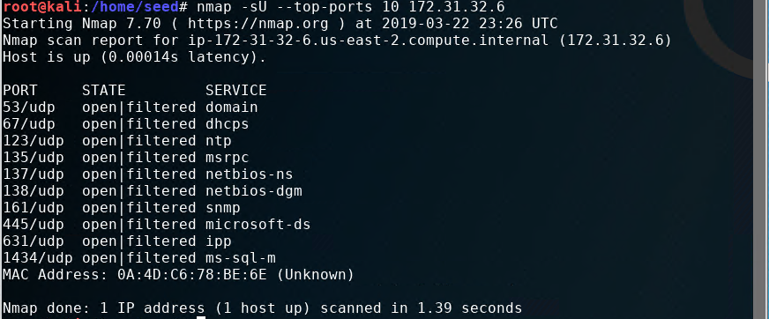

*Ping scan: This technique doesn’t scan for any ports, instead, it prints out the discovered host*

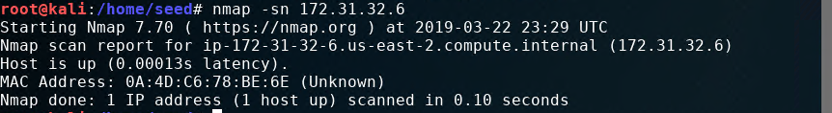

**Defense:** Ports scanning can defend using intrusion detection systems or firewalls. There are different ways to protect the ports from being scanned for each technique, such as monitoring number of ports connected to from a single origin over a period of time. Configuring the firewall properly can prevent most of the port scans. UDP scan and Ping scan can be prevented by blocking ICMP outbound. SYN Stealth scan can be prevented by blocking SYN packets.

**Fingerprinting Operating Systems:**

**Design:** I use nmap command below to run OS Fingerprinting:

nmap -O -v 172.31.32.6

**Observation:** It shows the victim’s OS is a cloud Linux OS. It also shows the ports, state and the associated services. A lot of information was exposed.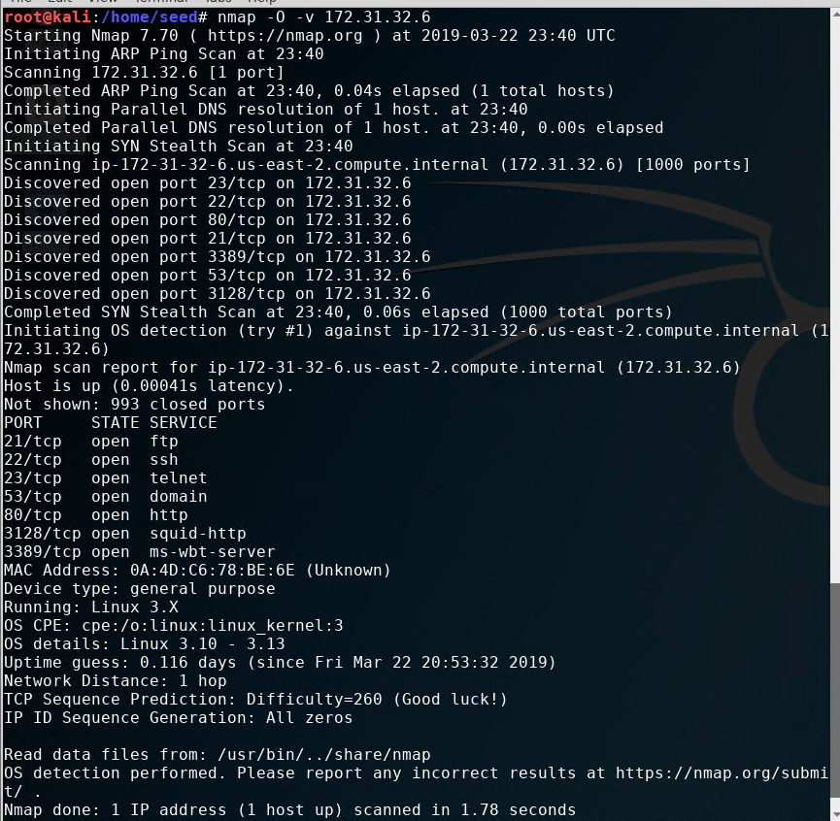

**Defense:** OS fingerprinting can be prevented by apply the concept of least privilege. In other words, only give privilege to necessary traffic.

**Task 2: SYN Flooding Attack**

**Design:** In this task, I setup 3 VMs : client, server, and attacker. In the acttacking VM, I used hping3 to flood the server. But firstly, I had to disable firewall rules on attacking VM and TCP SYN cookies on the server VM as shown below:

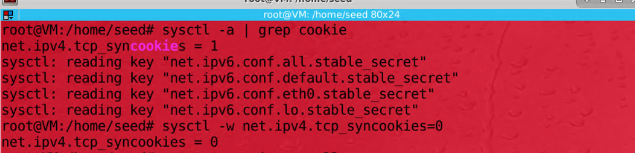

Turn of SYN cookies

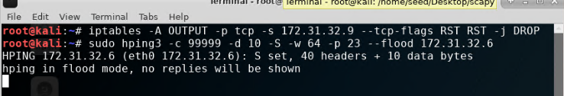

Disable firewall rules and run hping3 tool

**Observation:** Before the attack, I was able to telnet to server VM from client VM just fine. However, after the attack, the client could no longer connect to the server. By using the command “netstat -na | grep :23”, I observed that the server was receiving a large amount of SYN packages that led to SYN flood.

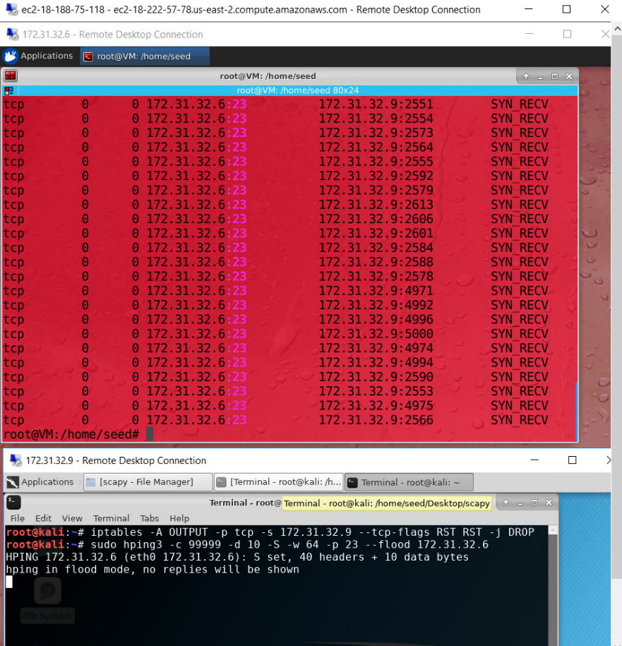

Server is flooded with SYN packages

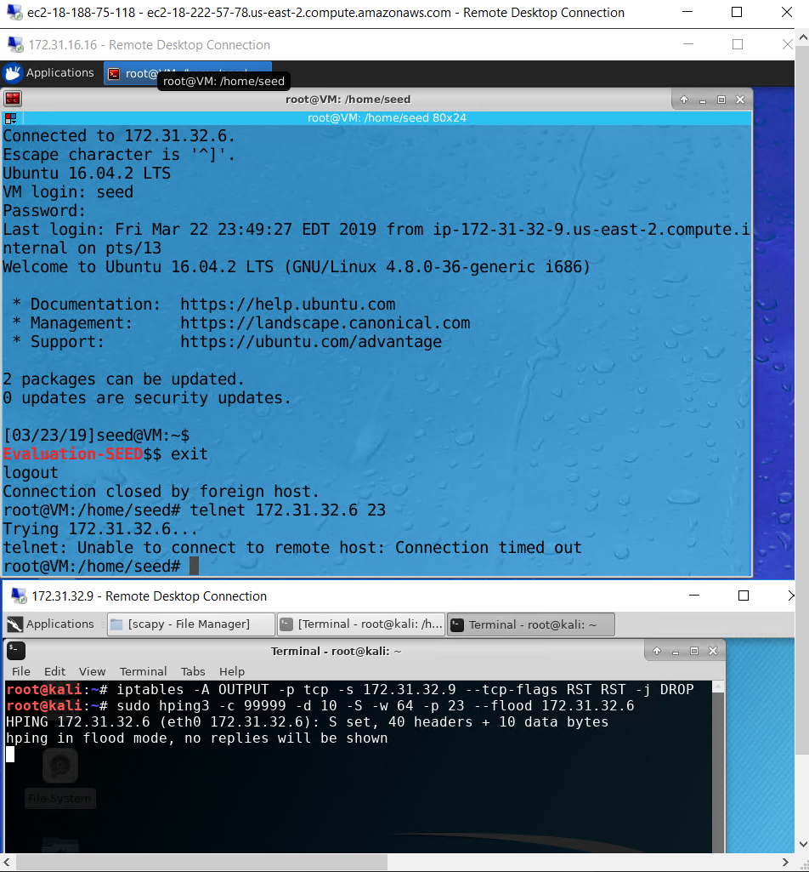

Client couldn’t connect to server after the attack

**Explanation:** As expected, the flood attack filled the SYN queue of the server and it could no longer receive any requests. The client could not connect to the server. It also slowed down the server a lot since there are too many requests at the same time. Turning off the SYN cookies discards SYN entries upon sending SYN-ACK when SYN queue is full. Therefore, the server could not release the SYN packages to empty the queue.

**Defense:** The best approach to prevent this attack is enabling SYN cookies. SYN cookies are calculated through a complicated process . The SYN cookies help validate the ACK package by checking the sequence number inside the package is valid or not. Another way is applying TCP Accept Policies. An outbound accept policy implements a firewall when trying to establish TCP connections with untrusted destinations. Large amount of unanswered SYN-ACKs can be detected and blocked. Another mechanism is the inbound accept policy. In this setup, an untrusted host must first complete the TCP handshake (SYN, SYN-ACK, ACK) with a firewall. The firewall then performs the TCP handshake with the protected server. A SYN flood would never reach the server as the firewall handles the attack instead of the server.

**Task 3: TCP RST Attacks on telnet and ssh Connections**

**Design:** In this is task, I setup telnet connection between client and server. After that I used another VM to interrupt and terminate the telnet connection. I repeated the same thing with SSH connection between the client and the server. I used the Scapy to send the TCP RST packet.

**Attack on Telnet:**

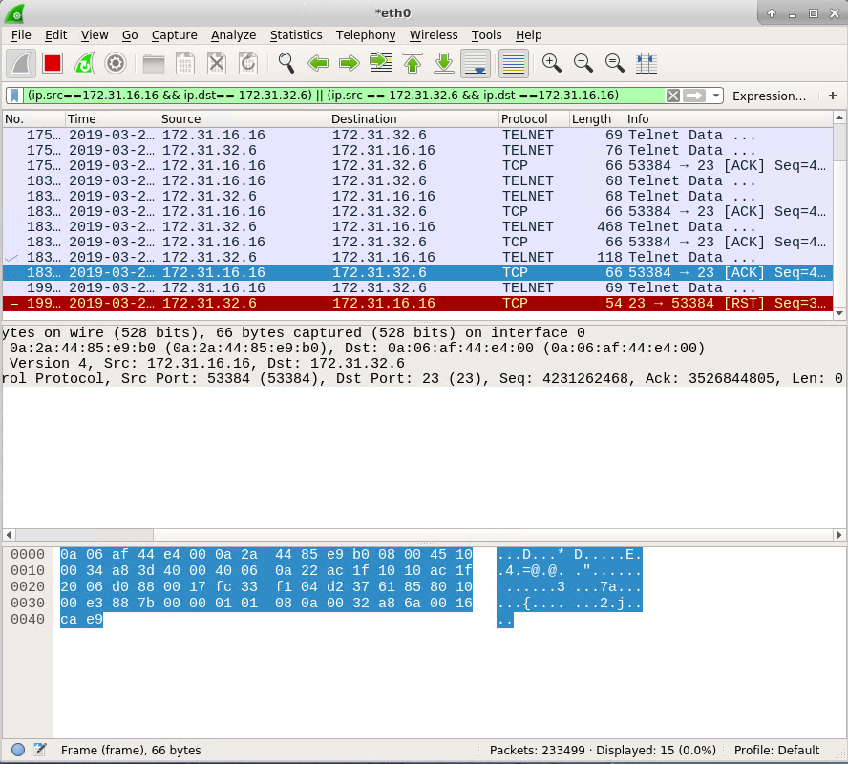

Getting port, Ack and Seq numbers from Wireshark

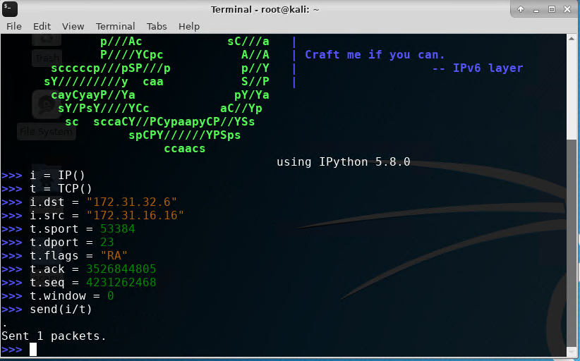

Construct and send TCP RST package using Scapy with values from Wireshark

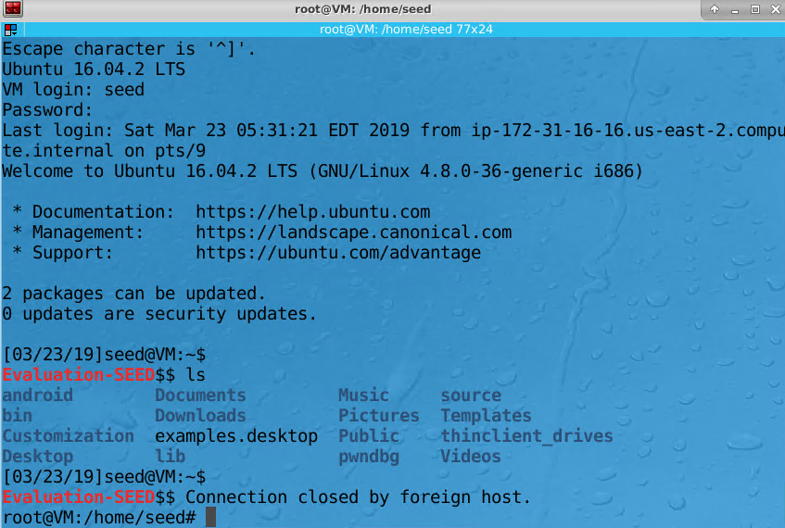

RST package terminates the Telnet connection

**Attack on SSH:**

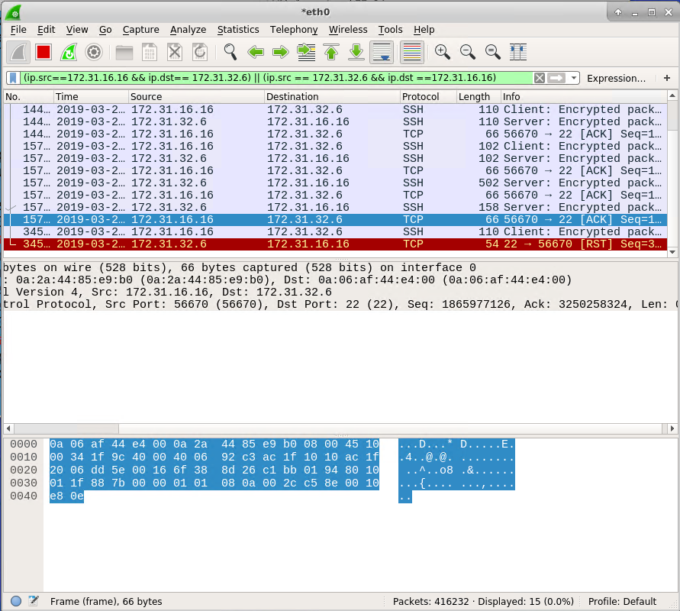

Getting port, Ack and Seq numbers from Wireshark

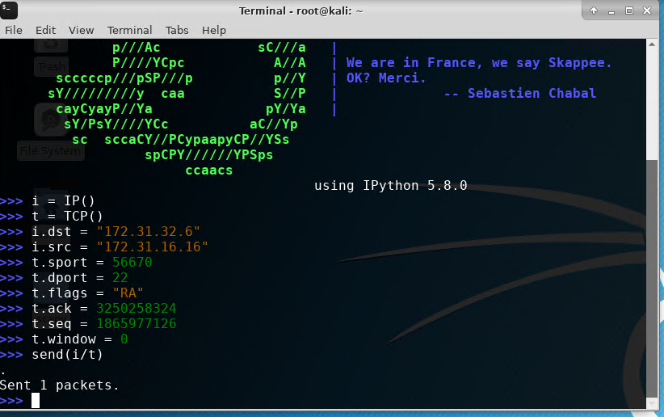

Construct and send RST package using Scapy with values from Wireshark

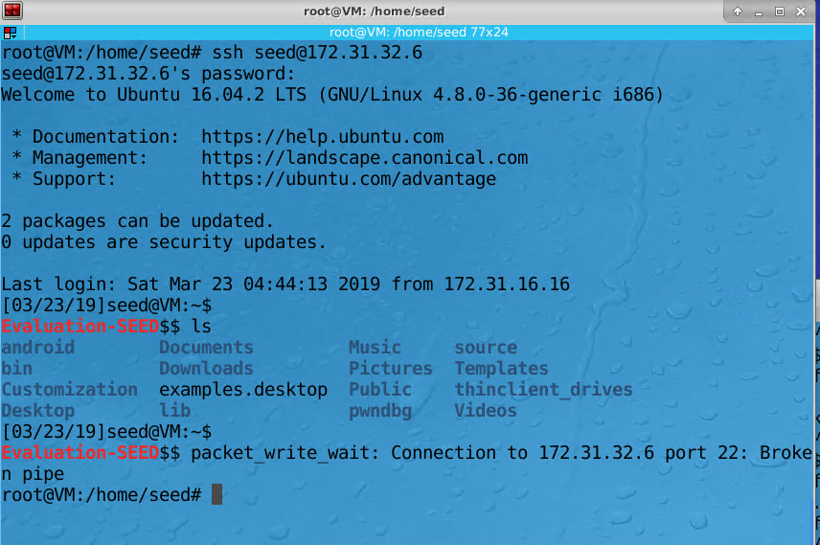

RST package terminates the SSH connection

**Explanation:** A RST packet can pre-emptively close a connection. By faking a package with Sequence and Acknowledge numbers obtained from Wireshark, the server will mistakenly receive that RST package from the attacker and close the connection with the RST flag.

**Defense:** To defend against this attack, authentication should be expanded beyond login session. Each IP packet should be authenticated each communication session. Another way to prevent this attack is using cryptographic keys and two-way authentication.

**Task 4: TCP Session Hijacking**

**Design:** In this task, I used netwox 40 tool to create and inject a fake package that contains an execution hex code in the victim’s VM (host). The netwox 40 command requires the parameters listed below:

|  |  |
| --- | --- |
| --ip4-src | Source IP address |
| --ip4-dst | Destination IP address |
| --tcp-src | Source TCP port |
| --tcp-dst | Destination TCP port |
| --tcp-seqnum | TCP Sequence number |
| --tcp-acknum | TCP Acknowledge number |
| --tcp-window | TCP window size |
| --tcp-data | Contains data sent over the network |
| --ip4-ttl | Lifespan of data |
| -z | No TCP Ack |

The values for the parameters above such as --ip4-src, --ip4-dst, --tcp-src, --tcp-dst, --tcp-seqnum, --tcp-acknum, --tcp-window can be obtained from the Wireshark on victim’s network.

The data sent was an execution hex code converted from the string “cat sercret.txt”. The file was saved under /home/seed/ in victim’s VM and would output “My name is Khanh Nguyen and this is task 4 HW4 CSCE465” when the hex code is executed.

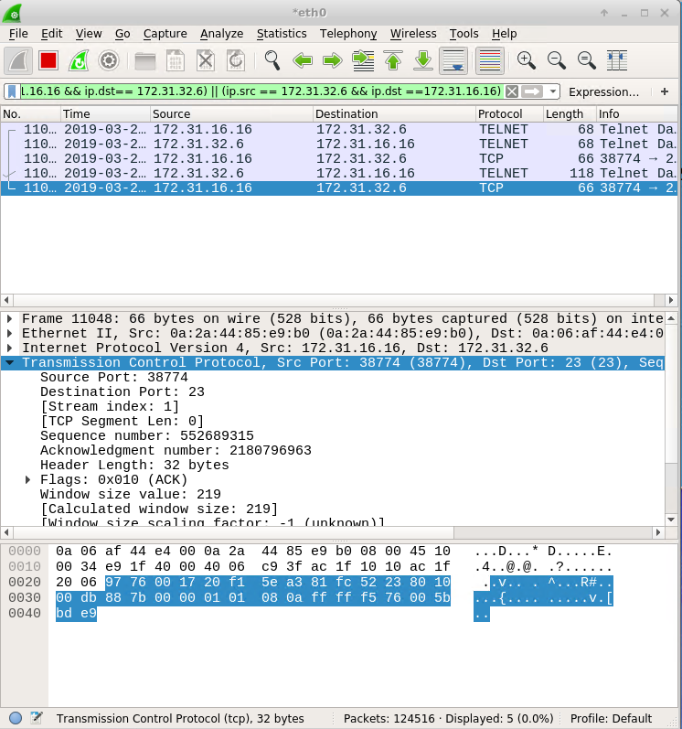

Obtain values for netwox 40 parameters in Wireshark

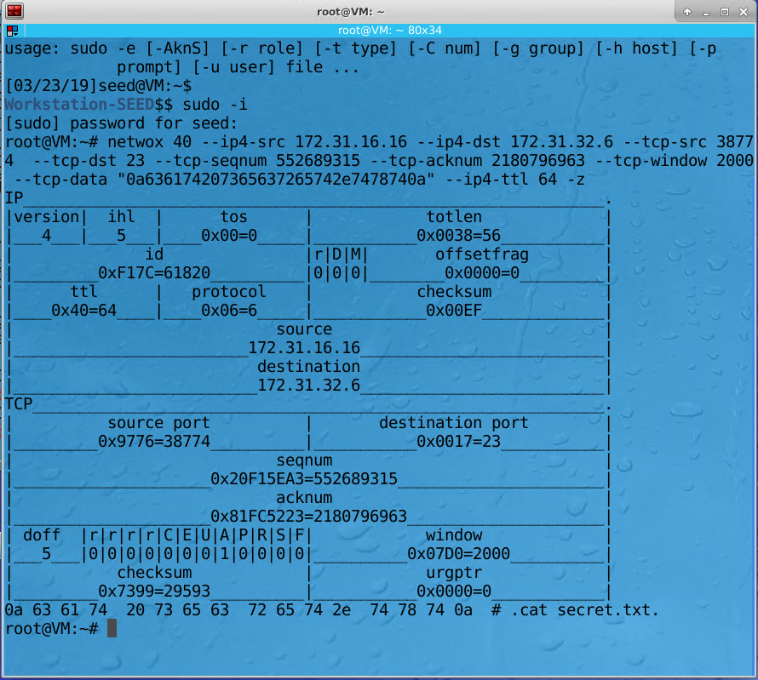

Hijacking package built and injected into network

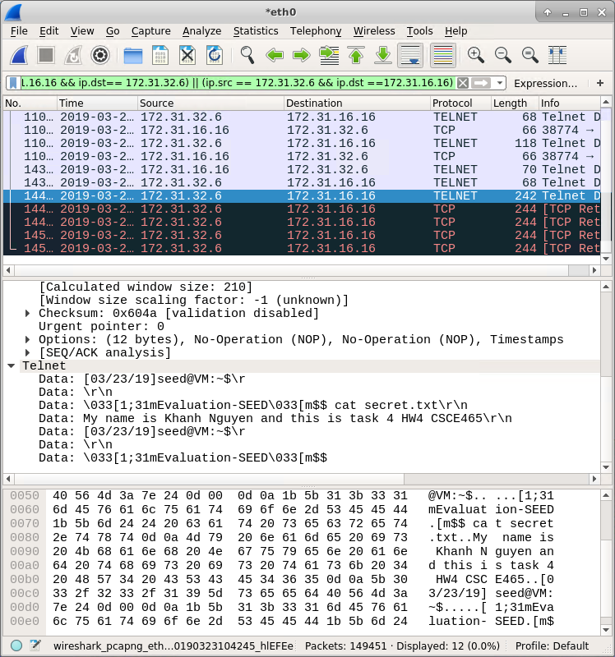

The hex was executed and output the content on telnet captured by Wireshark

**Observation:** The attack was successful as expected, the victim’s machine received the spoofed package the execute the hex code injected. There were many retransmissions since the spoofed package messed up the sequence number from user to server. Also, the user lost the control of telnet session. After a while, telnet just disconnected.

**Explanation:** When the server replies to the spoofed package, it takes sequence number created by the attacker. The package from user has not reached that number yet so it just discards the relies from server. Server thinks its package is lost so it keeps retransmitting the package. In other words, the server and user keep sending data to each other but they lost their trackings so they can’t receive any. In the end, it will result in disconnection since the transmissions slow down the connection.

**Defense:** SSL and TLS can prevent the attackers from getting the information needed to create the spoofed TCP packages. Encryption layouts are used to protect the transfer of data and information. Also, Initial Sequence Number technique will also help since the sequence number for each TCP session is completely random and cannot be guessed.

**Investigation:**

* **Initial Sequence Number(ISN)** are completely random and unpredictable since it is generated through a complicated process: after a server has received a SYN packet, it calculates a keyed hash from the information in the packet, including the IP addresses, port number, and sequence number, using a secret key that is only known to the server. This hash will be used as initial sequence number to start the transmissions between client and server.
* **TCP Window:**

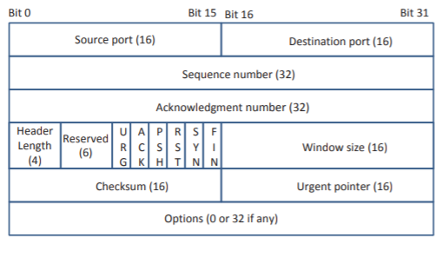

This window size is used to specify the rate at which data can be transferred between client and server. Its size depends on the receiver’s buffer. The purpose of window size is to stable the data flow and prevent data dropping. If the data is being send too fast or too much from the client more than what server’s buffer can hold or vice versa, it can help slow down data transmission.

* **Source Port Number:** Initially, the source port is random and really hard to predict. However, subsequent source ports are typically an increment of 1 or 2 of each other. It can give the attacker some clues to guess the exact number.